Generation Z in the Cashless Era: An Analysis of Digital Financial Literacy and Consumption Behavior

Meutia Maryam Sinuhaji ¹ *, Keisha Maritza Azzahra²,Muhammad Ariib Firaas³, Khalisha Azzahra Habibi⁴, Karunia Ramadhan⁵
^{1,2,3,4,5}SMA Al–Azhar Medan
E-mail: meutiamaryam@gmail.com
*Corresponding Author
https://doi.org/10.31004/jerkin.v4i2.3948
ARTICLE INFO | ABSTRACT
Article history  Received: 20 November 2025  Revised: 26 November 2025  Accepted: 5 Desember 2025  Kata Kunci :  Generasi Z, literasi keuangan digital, perilaku konsumsi, cashless society.  Keywords  Generation Z, digital financial literacy, consumption behavior, cashless society.   | Penelitian ini bertujuan untuk menganalisis hubungan antara literasi keuangan digital dan perilaku konsumsi Generasi Z di era cashless. Kemajuan teknologi dan sistem pembayaran non-tunai telah mendorong perubahan signifikan dalam pola konsumsi masyarakat, khususnya di kalangan Generasi Z yang dikenal sebagai pengguna aktif layanan keuangan digital seperti e-wallet, mobile banking, dan QRIS. Metode penelitian yang digunakan adalah deskriptif kuantitatif dengan teknik pengumpulan data melalui kuesioner yang disebarkan kepada 71 responden. Hasil penelitian menunjukkan bahwa Generasi Z memiliki tingkat literasi keuangan digital yang cukup baik dari aspek teknis, namun masih rendah dalam pengelolaan keuangan dan kesadaran risiko finansial. Kemudahan transaksi dan promosi digital terbukti mendorong perilaku konsumtif, terutama pada individu dengan tingkat literasi keuangan rendah. Oleh karena itu, peningkatan literasi keuangan digital menjadi kunci penting untuk membentuk perilaku konsumsi yang bijak dan mendukung terciptanya ekosistem ekonomi digital yang sehat dan berkelanjutan di Indonesia.
This study aims to analyze the relationship between digital financial literacy and Generation Z's consumption behavior in the cashless era. Technological advancements and cashless payment systems have driven significant changes in people's consumption patterns, especially among Generation Z, who are known as active users of digital financial services such as e-wallets, mobile banking, and QRIS. The research method used was quantitative descriptive, with data collection techniques through questionnaires distributed to 71 respondents. The results of the study show that Generation Z has a fairly good level of digital financial literacy from the technical aspect, but it is still low in financial management and financial risk awareness. The ease of transactions and digital promotions has been shown to encourage consumptive behavior, especially in individuals with low levels of financial literacy. Therefore, increasing digital financial literacy is an important key to shaping wise consumption behavior and supporting the creation of a healthy and sustainable digital economy ecosystem in Indonesia
This is an open access article under the CC–BY-SA license.
How to Cite: Meutia Maryam Sinuhaji , et al (2025) Generation Z in the Cashless Era: An Analysis of Digital Financial Literacy and Consumption Behavior . 4(2) 12027- 12034 https://doi.org/10.31004/jerkin.v4i2.3948
INTRODUCTION
Advances in information technology and digitalization have changed the financial transaction system in Indonesia from cash-based to cashless. Based on a survey by the Ministry of Communication and Information Technology (Kominfo) with the Katadata Insight Center, around 65.4% of Indonesians have used digital wallets, with the GoPay (71%) and OVO (70%) platforms being the two most popular services (Tanjung et al., 2024). This behavior change is also driven by the National Non-Cash Movement (GNNT) policy launched by Bank Indonesia on 14 August 2014, as a step towards a Less-Cash Society and part of the strategy to strengthen the national digital economy ecosystem(Kartika et al., 2023). In the context of the Industrial Revolution 4.0, digital payment systems play an important role in increasing transaction efficiency and reducing the risk of inflation due to the large amount of cash circulating in the community(Tarantang et al., 2019). The implementation of the cashless system is now also increasingly widespread among major campuses in Indonesia, such as the University of Indonesia and the Bandung Institute of Technology, where various internal transactions such as canteen payments and student administration have been carried out through QRIS and e-wallets (Anjeli et al., 2025).
Generation Z, born between 1997 and 2012, is a group that grew up amid the rapid development of the internet, smartphones, and social media, making it the most adaptive generation to modern financial technology. Based on data from the Ministry of Communication and Information, the number of Gen Z population reaches around 74.93 million people or 27.94% of the total population of Indonesia, and most of them have actively used digital-based financial services such as mobile banking and electronic wallets(Elsalonika & Ida, 2025). This phenomenon is in line with the results of research by Maisa et al. (2025), which show that the use of cashless payment systems has a positive and significant influence on the consumptive behavior of Gen Z in Tasikmalaya. In addition, the study by Maharani and Bidhari (2025) found that nine out of ten Gen Z respondents spend more than IDR 900,000 per month on small expenses such as coffee, skincare, and digital subscriptions, illustrating the trend of impulsive consumption in the digital age. This condition is strengthened by Rahmatika's research et al. (2024), which emphasizes that although the cashless system increases efficiency, the ease of access to transactions can actually encourage consumptive behavior if it is not balanced with adequate financial literacy. Thus, the dominance of Gen Z in the use of financial technology is an important phenomenon that needs to be balanced with increased understanding and wise financial management so as not to be trapped in a consumptive lifestyle (Rahmatika et al., 2024).
Digital financial literacy has an important role in shaping healthy financial behavior in the modern era. This literacy includes not only the ability to use financial applications such as e-wallets or mobile banking, but also the ability to manage personal finances wisely and responsibly. The results of the 2025 National Survey on Financial Literacy and Inclusion (SNLIK) conducted by the Financial Services Authority (OJK) show that the national financial literacy index reached 66.46%, while the financial inclusion index reached 80.51%, an increase compared to the previous year (OJK, 2025). Digital financial literacy has an important role in shaping healthy financial behavior in the modern era. This literacy includes not only the ability to use financial applications such as e-wallets or mobile banking, but also the ability to manage personal finances wisely and responsibly. The results of the 2025 National Survey on Financial Literacy and Inclusion (SNLIK) conducted by the Financial Services Authority (OJK) show that the national financial literacy index reached 66.46%, while the financial inclusion index reached 80.51%, an increase compared to the previous year (Aziatin, 2024).
The phenomenon of Generation Z's consumption behavior shows a significant shift in the shopping patterns of modern society. Practical lifestyles, social media trends, and the need for instant gratification encourage this generation to behave consumptively and impulsively in transactions. Generation Z, who grew up in the midst of the digital era, has made online shopping, food delivery services, and the use of the buy now pay later (BNPL) system part of their daily routine (Gurning, 2025). The convenience of cashless payment systems and digital promotions such as cashback, flash sales, and free shipping reinforces the tendency of spontaneous consumption that reflects the latte factor phenomenon, which is the accumulation of small expenses that are made repeatedly without realizing it (Maharani & Bidhari, 2025). In addition, research by Aziatin (2024) shows that a consumptive lifestyle influenced by social media and low financial literacy are the main causes of weak financial management among the younger generation. This condition raises the question of the extent to which digital financial literacy can play a role in controlling the consumptive behavior of Generation Z in the cashless era.
The urgency of this research lies in the importance of understanding the relationship between digital financial literacy and Generation Z's growing consumption behavior amid advances in financial technology and the dominance of non-cash transactions. As the generation that is most active in using digital financial services, Gen Z has the potential to face the risk of consumptive behavior and suboptimal financial management if they do not have an adequate level of financial literacy. This research is expected to provide a comprehensive picture of the level of readiness of Generation Z in the face of an increasingly complex digital economy system, as well as identify factors that influence their financial decision-making. The findings of this study can also be the basis for the formulation of more targeted financial education policies, especially in the context of increasing digital financial literacy among the younger generation, so that they are able to adapt and participate wisely in the digital economy ecosystem.
This study uses a quantitative descriptive approach, which is a research method that aims to describe phenomena that occur systematically, factually, and accurately based on numerical data from respondents (Sugiyono, 2023). This approach is used to obtain an objective picture of the relationship between the research variables without manipulating the conditions being studied. The quantitative descriptive method emphasizes data collection through standardized instruments such as questionnaires or closed questionnaires, which contain measured statements and are compiled based on the indicators of research variables. The data collection technique in this study was carried out by distributing questionnaires to predetermined respondents, either online using Google Form or directly (offline). The questionnaire was chosen because it was able to collect data from a large number of respondents in a short period of time, and allowed researchers to quantitatively measure respondents (Sugiyono, 2023).
Furthermore, the data analysis technique used is descriptive analysis, which involves analyzing data by grouping, calculating frequencies, and presenting the results in the form of tables, charts, and graphs to illustrate the tendency of respondents' answers to each indicator. This analysis is not intended to test hypotheses, but to present an overview of the phenomenon being studied (Sugiyono, 2023, hlm. 204–205). Thus, this quantitative descriptive method helps researchers understand the empirical conditions of the research object in a systematic and measurable manner.
RESULTS AND DISCUSSION
General Description of Respondents (Generation Z)
The results of the questionnaire distribution involving 73 Generation Z respondents provide an overview of the demographic characteristics of the group that is the focus of this study. Generation Z is an age group born between 1997 and 2012, known as the digital native generation because they grew up in the midst of the development of information technology, the internet, and social media. Based on the survey results, the majority of respondents were in the age range of 16–20 years (84.9%), followed by 21–25 years (8.2%), and a small percentage were aged 10–15 years (6.8%). These findings show that the majority of respondents are classified as late adolescents to early adulthood, which is an age group that is actively pursuing education and beginning to have financial independence.
Based on gender, female respondents dominated with a percentage of 61.6% (45 people), while men were 38.4% (28 people). This difference in proportion shows that women are relatively more active in filling out surveys related to digital financial behavior. This is in line with the findings of Maharani dan Bidhari (2025), which revealed that women tend to have a higher level of digital consumption activity than men, especially in the purchase of lifestyle products and daily necessities through e-commerce platforms and digital wallets.
In terms of the last education, the majority of respondents are taking the high school/vocational level (60.3%), followed by S1 (28.8%), and junior high school (9.6%), while the rest stated that they are studying S1 (1.3%). These findings reinforce that Generation Z in this study is mostly still students and students who are active in the academic environment and have a high dependence on digital technology to support learning activities and daily needs.
As for employment status, as many as 69.9% of respondents are students, while 30.1% are students, and none of the respondents are full-time employed. This illustrates that the majority of respondents are still in the formal education stage and do not have a fixed income. Thus, their consumption behavior is greatly influenced by the ease of access to non-cash transactions, digital promotions, and social factors such as social media trends and recommendations. This phenomenon is consistent with the results of Gurning's research (2025), which explains that easy access to digital payment systems and online promotions is the main driver of Generation Z's consumptive behavior in the cashless era.
In terms of internet usage intensity, the majority of respondents used the internet more than 6 hours per day (43.8%), followed by 4–6 hours (41.1%), 1–3 hours (12.3%), and only a small percentage used the internet less than 1 hour per day (2.7%). This fact shows that Generation Z has a very high level of digital exposure, both for entertainment, communication, online learning, and economic activities such as online shopping and e-wallet transactions. This also supports the findings of Rahmatika et al. (2024), who affirm that high digital exposure in Generation Z accelerates the adoption of financial technology while increasing the risk of consumptive behavior if it is not balanced with adequate financial literacy.
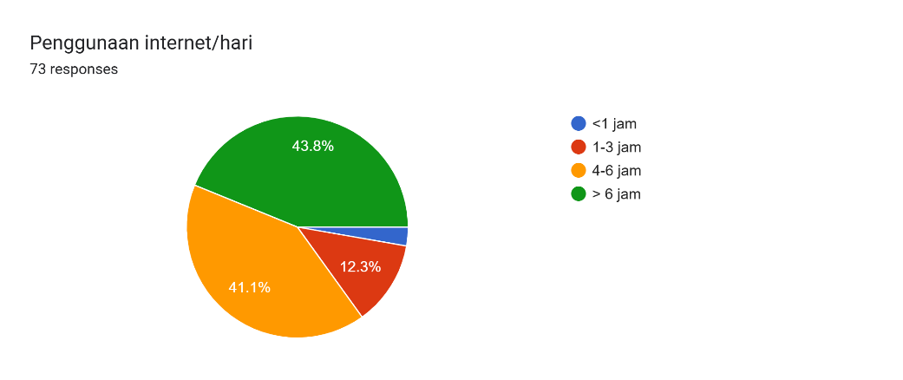
Figure 1. Diagram of Duration of Internet Use per Day
Overall, the characteristics of respondents show that Generation Z is a very digitally active group with high levels of internet use and access to non-cash financial services. Most are still in the formal education stage, do not have a fixed income, but have a large intensity of digital transactions. This condition strengthens the relevance of research on the influence of digital financial literacy on the consumption behavior of Generation Z, because this age group is the main user of the non-cash payment system in Indonesia, which is most vulnerable to consumptive behavior due to the ease of access to digital transactions and promotions (Tanjung et al., 2024; Rahmatika et al., 2024).
Digital Financial Literacy Level of Generation Z
The results show that the level of digital financial literacy among Generation Z is quite good, with most respondents understanding the functions, benefits, and risks of using digital financial services. This can be seen from their perception of security, convenience, and practicality in transacting using various digital platforms such as e-wallets, mobile banking, and QRIS.
Most respondents stated that they understood the difference in features between e-wallets, mobile banking, and digital cards, with the highest scores being in the "agree" (32.9%) and "strongly agree" (38.4%) categories, while only 4.1% chose the low category. These findings show that Generation Z is not just a user, but also has basic knowledge regarding the types and functions of various cashless payment instruments. This condition is in line with the research of Elsalonika and Ida (2025), which states that the young age group has a high adaptability to financial technology because they are used to using digital devices from an early age.
In terms of risk understanding, most respondents assessed that digital transactions are relatively safe from fraud or theft, with 45.2% choosing the category "3" (neutral), 27.4% "4" (agree), and 15.1% "5" (strongly agree). A few respondents felt doubtful or disagreed with the security of digital payment systems. This shows that even though Generation Z is used to digital payments, there is still a need to improve transaction security literacy so that users are more aware of risks such as phishing and data leaks.
In addition, the majority of respondents considered that payments via QRIS or e-wallets were much faster and more practical than cash, with 54.8% stating "strongly agree" and 21.9% "agreeing". Only 4.1% chose the low category. This shows that efficiency is the dominant factor in the acceptance of digital financial technology by Generation Z, in line with research by Tanjung et al. (2024), which confirms that the development of the cashless ecosystem is influenced by the increasing interest of the younger generation in time efficiency and ease of transactions.
In terms of technical capabilities, the majority of respondents found the payment app interface easy to understand, with 34.2% answering "agreed" and 31.5% "strongly agreed". In addition, the top-up and transfer process was considered to be running smoothly by 45.2% of respondents in the "4" category (agreed) and 13.7% in the "5" category (strongly agreed). This shows that Generation Z has good technical skills in using digital financial applications, including menu navigation and transaction balance management.
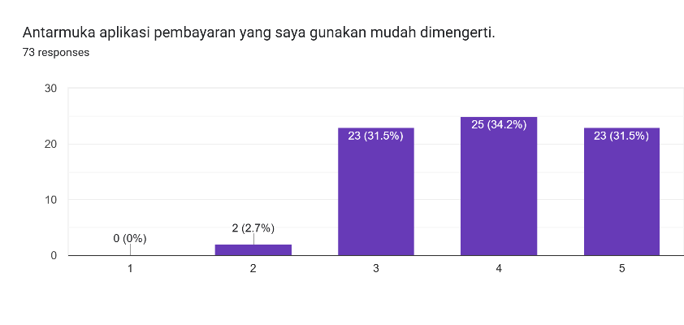
Figure 1. Ease of Interface and Transaction Top-up Diagram
When comparing the high-literacy group (who understand the app's features and security) and the low-literacy group (who only use without understanding the detailed functions), there is a difference in financial behavior patterns. Groups with high literacy tend to use digital payments for productive transactions such as purchasing necessities, paying for education, and topping up online transportation. In contrast, groups with low literacy more often use digital wallets for consumptive needs such as online shopping, entertainment subscriptions, and cashback promos.

Some respondents also wrote about their experiences, such as:
"I bought skincare products because there were many promotions on social media, but they turned out not to be suitable."
"I like to be tempted by massive discounts when the goods are not really needed."
These findings show that some Generation Z are still unable to control their consumption behavior wisely, especially when faced with digital promotions and instant payment features.
From the results of the analysis, several factors affect the level of digital financial literacy of Generation Z, including: The level of education, where high school students and college students exhibit different digital adaptability. Personal experience, such as how often to make digital transactions and whether or not they have experienced security issues. Information sources are mostly obtained from social media, peers, or educational content on digital platforms. The social environment, which also influences consumption behavior due to the trend of using payment apps, is often triggered by community recommendations and influencers.
These factors are in line with the results of Aziatin's (2024) research, which states that digital financial literacy is influenced by a combination of formal education and exposure to digital information. The higher the user's knowledge and experience of financial services, the better their ability to manage finances responsibly in the cashless era.
Overall, the level of digital financial literacy of Generation Z in this study can be categorized as quite good, but not evenly distributed. Respondents have mastered the technical aspects of using financial applications, but there is still a need for improvement in their understanding of risk and personal financial management. This condition strengthens the urgency of research on the relationship between digital financial literacy and consumption behavior, as stated by Rahmatika et al. (2024) and Maisa et al. (2025), that without good financial literacy, easy access to digital transactions has the potential to encourage consumptive behavior among Generation Z.
Analysis of Generation Z's Consumption Behavior in the Cashless Era
The development of digital payment systems provides significant convenience for Generation Z in conducting daily financial transactions. Based on the results of a survey of 73 respondents, the majority showed a high frequency of use of digital payment instruments, both through e-wallets, mobile banking, and QRIS. Most respondents use digital payment services for almost all small transactions, such as snacks, transportation, and online shopping, with 38.4% of respondents choosing the "4" category (often) and 34.2% the "3" category (quite often). These findings show that cashless systems have become an integral part of Generation Z's lifestyle, which is synonymous with efficiency, practicality, and digital connectivity.
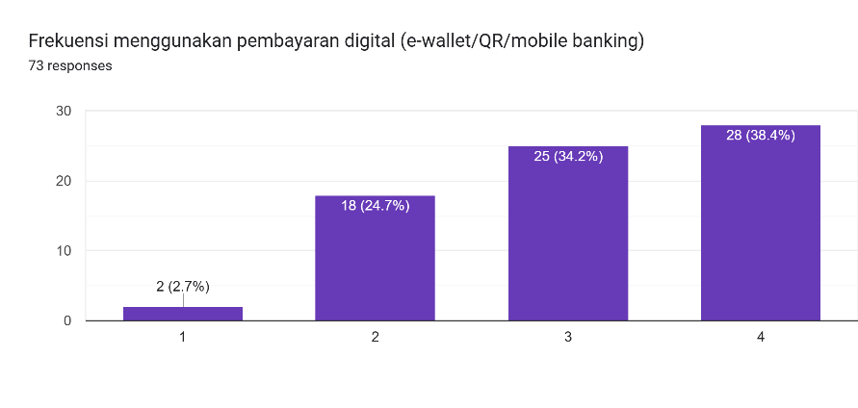
Figure 1. Digital Payment Usage Frequency Chart
From the results of the questionnaire, it was found that the majority of respondents felt that digital transactions were faster and more practical than cash payments, with 54.8% stating "strongly agree" and 21.9% "agree". In addition, 46.6% of respondents chose the category "3" (neutral) and 21.9% "5" (strongly agree) for the statement "I make more impulse purchases when paying non-cash", indicating a tendency towards more spontaneous consumptive behavior due to the convenience of digital systems. This phenomenon is in line with the findings of Maisa et al. (2025), who stated that the ease of electronic transactions increases the consumptive tendencies of Generation Z, especially in small expenses such as food, fashion, and digital entertainment.
The types of expenditure of respondents in this study are mostly related to secondary and tertiary needs, such as the purchase of ready-to-eat food, skincare, digital entertainment subscriptions (Netflix, Spotify), and online shopping for fashion products and accessories. Only a small percentage of respondents use e-wallets for productive needs such as education payments or public transportation. This consumption pattern shows that digital promotions such as cashback, flash sales, and free shipping are the dominant factors that influence purchasing decisions. This finding is reinforced by Gurning (2025), who explains that digital promotion has a psychological effect in the form of instant gratification, which is momentary gratification that encourages impulsive behavior in young consumers.
Some respondents also mentioned that they often regretted making impulse purchases because they were tempted by digital promos. One of the respondents wrote:
"I bought skincare products because there were many promotions on social media, but they turned out not to be suitable."
While another respondent said:
"I like to be tempted by massive discounts even though the goods are not really needed.
This quote shows that impulsive behavior is still quite strong among Generation Z and is often triggered by the influence of social media, digital consumption trends, and social pressure from the peer environment.
The Buy Now Pay Later (BNPL) phenomenon is also increasingly popular among Generation Z. Although not all respondents use this feature, some admitted that they were interested because the installment system without a credit card is considered to facilitate access to the desired goods. However, this behavior has the potential to cause consumptive debt if it is not balanced with good financial literacy. This condition is in line with the statement of Rahmatika et al. (2024), who affirm that digital payment systems, although efficient, can increase personal financial risks due to weak control over spending.
In addition to technological factors, Generation Z's consumption behavior is also greatly influenced by social influences such as fear of missing out (FOMO) and social media trends. Many respondents admitted to making purchases because of recommendations from influencers, peers, or ads on TikTok and Instagram, which shows that digital consumption is not only functional, but also symbolic and social, as a way to maintain one's existence and adjust to group norms.
Overall, the results of this study show that the ease of digital transactions and exposure to social media have a significant influence on the consumption behavior of Generation Z. Their consumption patterns are dominated by impulse purchases, social impulses, and preferences for digital convenience, but are not fully accompanied by awareness of balanced financial management. This condition emphasizes the importance of increasing digital financial literacy so that Generation Z can enjoy the convenience of financial technology without being trapped in a consumptive lifestyle in the cashless era (Rahmatika et al., 2024; Maisa et al., 2025; Gurning, 2025).
Implications of Research Findings
The findings of this study have important implications for the policy direction and strategy of increasing digital financial literacy among the younger generation, especially Generation Z. The results of the study show that technological advances and non-cash payment systems have a significant impact on the consumption patterns and financial management of this generation. Therefore, a digital financial education policy that is more adaptive and contextual to their digital habits and lifestyles is needed. Educational institutions are expected to be able to integrate digital financial literacy materials into the curriculum or project-based learning activities, so that students are not only active users of financial technology, but also able to manage it wisely. The government, through the Financial Services Authority (OJK) and related agencies, needs to expand financial literacy programs targeting the age group of 15-25 years old with an interactive and digital media-based approach. Meanwhile, digital financial platforms such as e-wallets and the buy now pay later application are expected to play an active role in including educational features that are transparent and easily accessible to users. More broadly, these findings reflect the changing financial lifestyle of Generation Z in the context of a cashless society, where ease of access to transactions must be balanced with increased awareness of personal financial planning and responsibility so that the sustainability of the digital economy can be achieved healthily and inclusively.
CONCLUSION
Based on the results of the research that has been conducted, it can be concluded that Generation Z in Indonesia has a high level of adoption of digital financial systems such as e-wallets, mobile banking, and QRIS, but it has not been fully balanced with adequate financial literacy. The ease of access to cashless transactions and various digital promotions has been shown to encourage consumptive and impulsive behaviors, especially in individuals with low levels of financial literacy. Although most respondents have mastered the technical aspects of using digital financial applications, there are still weaknesses in the ability to manage personal finances and understand financial risks. Therefore, digital financial literacy has an important role in shaping wise consumption behavior in the cashless era, where increased education and financial awareness are key factors so that Generation Z can take advantage of financial technology advances intelligently and responsibly, as well as contribute to the creation of a healthy and sustainable digital economy ecosystem.
ACKNOWLEDGMENT
The researcher would like to express his deepest gratitude to Al Azhar Medan Superior High School for providing support, guidance, and facilities during the implementation process of this research. Thank you to the supervisors who have provided very meaningful direction, motivation, and input so that the researcher can complete this research well. The researcher also thanked all respondents and research participants who had taken the time to contribute to filling out the questionnaire so that the research data could be collected completely. Not to forget, the researcher expressed his gratitude to parents and friends who always provided moral support and enthusiasm throughout the research process. Finally, the researcher appreciates all parties who cannot be mentioned one by one but have provided help and support so that this research can be completed. Hopefully, all this goodness will get the best reply.
REFERENCES
Anjeli, R., Putri, D. C. S., Perengki, M., & Soleh, E. (2025). Penggunaan Cashless Di Lingkungan Mahasiswa (T. Hardianti, K. Setyagustina, & Salahuddin (eds.)). Penerbit Widina Media Utama.
Aziatin, W. (2024). Pengaruh Literasi Keuangan Dan Gaya Hidup Terhadap Pengelolaan Keuangan Tenaga Kerja Muda. KEIZAI: Jurnal Kajian Ekonomi, Manajemen, & Akuntansi, 5(2), 184–198.
Elsalonika, A., & Ida. (2025). Perilaku Keuangan Generasi Z: Peran Penerapan Financial Technology, Literasi Keuangan, Dan Efikasi Diri. Jurnal Manajemen Bisnis Dan Kewirausahaan, 9(2), 365–379.
Gurning, J. S. P. (2025). Transaksi Belanja Online Melalui Paylater Pada Masyarakat di Kota Pekanbaru. Jurnal Ilmiah Wahana Pendidikan, 11(2.B), 109–123.
Kartika, A., Nurbaiti, & Aslami, N. (2023). Pengaruh Gerakan Nasional Non Tunai, Social Influence, Dan Persepsi Kemudahan Penggunaan Terhadap Minat Menggunakan Digital Payment Dalam Konsep Maslahah (Studi Kasus : Kota Kisaran). Jurnal Manajemen Akuntansi (JUMSI), 3(1), 161–174.
Maharani, C. V., & Bidhari, S. C. (2025). Fenomena Latte Factor Pada Generasi Z Jabodetabek: Pengaruh Cashless Society, Promosi Digital, Dan Literasi Keuangan. Jurnal Maneksi (Management Ekonomi Dan Akuntansi), 14(3), 1362–1374.
Maisa, T. R., Jalaludin, S. M., & Burhani, H. H. (2025). Pengaruh Penggunaan Sistem Cashless Terhadap Perilaku Konsumtif Gen Z Tasikmalaya. Indo-Fintech Intellectuals: Journal of Economics and Business, 5(2), 5263–5274.
OJK. (2025). Siaran Pers Bersama: Indeks Literasi dan Inklusi Keuangan Masyarakat Meningkat, OJK dan BPS Umumkan Hasil Survei Nasional Literasi Dan Inklusi Keuangan (SNLIK) Tahun 2025. https://ojk.go.id/id/berita-dan-kegiatan/siaran-pers/Pages/OJK-dan-BPS-Umumkan-Hasil-Survei-Nasional-Literasi-Dan-Inklusi-Keuangan-SNLIK-Tahun-2025.aspx
Rahmatika, Ariani, F., & Susanti, R. (2024). Pengaruh Cashless Society dan Literasi Keuangan terhadap Perilaku Konsumtif Gen Z di Kota Padang. Shar-E : Jurnal Kajian Ekonomi Hukum Syariah, 10(2), 172–185.
Sugiyono. (2023). Metode Peneltian Kuantitatif, Kualitatif, dan R&D (5th ed.). Alfabeta.
Tanjung, A., Tobing, C. T. L., Ar, N. A., & Pane, S. G. (2024). Analisis Sistem Pembayaran Menggunakan Dompet Digital Payment System Analysis Using Digital Wallet. Journal of Information Technology and Computer Science (INTECOMS), 7(1).
Tarantang, J., Awwaliyah, A., Astuti, M., & Munawaroh, M. (2019). Perkembangan Sistem Pembayaran Digital Pada Era Revolusi Industri 4.0 Di Indonesia. Jurnal Al Qardh, 4, 60–75.

